The web should be fast. Executive Summary



Performance Report for:

<https://othoba.com/>

Report generated: Wed, Oct 27, 2021 2:55 AM -0700

Test Server Location:

Using:

Vancouver, Canada

Chrome (Desktop) 90.0.4430.212, Lighthouse 8.3.0

|  |  |  |
| --- | --- | --- |
|  | Performance  37% | Structure  71% |

|  |  |  |
| --- | --- | --- |
| L. Contentful Paint  2.3s | T. Blocking Time  487ms | C. Layout Shift  0.54 |

Top Issues



**IMPACT AUDIT**

|  |  |  |
| --- | --- | --- |
| High | **Avoid enormous network payloads** | Total size was 5.74MB |
| Med-High | **Avoid an excessive DOM size** | 4,261 elements |
| Med | **Avoid large layout shifts** | 5 elements found |
| Med-Low | **Serve static assets with an efficient cache policy** | Potential savings of 286KB |
| Med-Low | **Use a Content Delivery Network (CDN)** | 20 resources found |

Page Details

Total Page Size - 5.74MB

4.1s

**Fully Loaded Time**



How does this affect me?

Today's web user expects a fast and seamless website experience. Delivering that fast experience can result in increased visits, conversions and overall happiness.

As if you didn't need more incentive, **Google has announced that they are using page speed in their ranking algorithm.**

About GTmetrix

GTmetrix is developed by the good folks at **Carbon60**, a Canadian hosting company with over 25 years experience in web technology.

<https://carbon60.com/>

Other 628KB

IMG 4.32MB

Total Page Requests - 201

IMG 83.1%

HTML JS

CSS

IMG

Video

Font

Other

History



Page scores

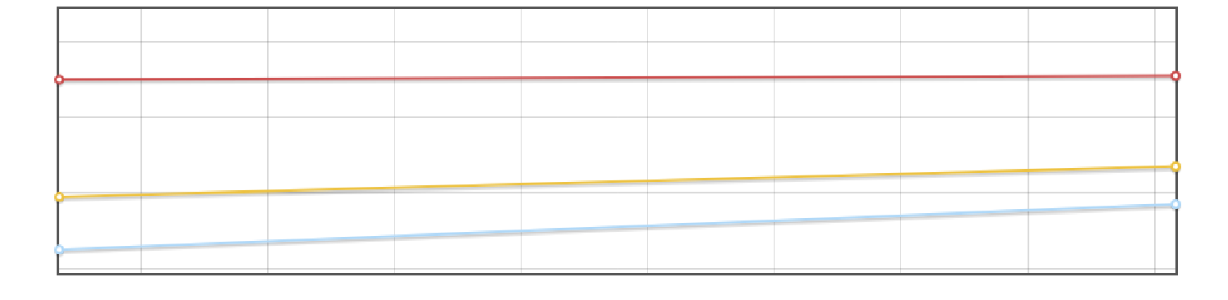

80%

60%

40%

20%

Oct 27 02:15AM Oct 27 02:20AM Oct 27 02:25AM Oct 27 02:30AM Oct 27 02:35AM Oct 27 02:40AM Oct 27 02:45AM Oct 27 02:50AM Oct 27 02:55AM

GTmetrix Grade

Performance Score

Structure Score

Page metrics

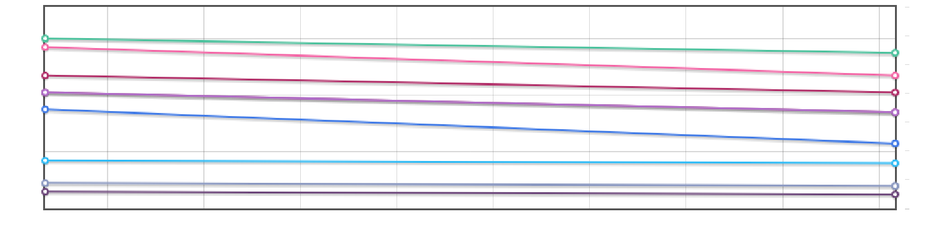

0.7

6s

0.6

0.5

4s

0.4

0.3

2s

0.2

0.1

0s 0.0

Oct 27 02:15AM Oct 27 02:20AM Oct 27 02:25AM Oct 27 02:30AM Oct 27 02:35AM Oct 27 02:40AM Oct 27 02:45AM Oct 27 02:50AM Oct 27 02:55AM

Time to First Byte Fully Loaded

First Contentful Paint Total Blocking Time

Largest Contentful Paint Speed Index

Onload Time Cumulative Layout Shift

Time to Interactive

Page sizes and request counts

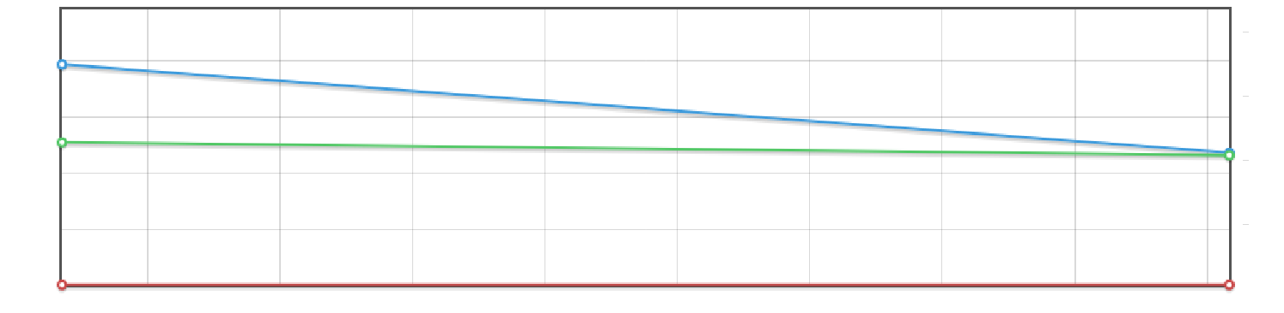

250

9.54MB

225

7.15MB

200

4.77MB

2.38MB

175

Oct 27 02:15AM Oct 27 02:20AM Oct 27 02:25AM Oct 27 02:30AM Oct 27 02:35AM Oct 27 02:40AM Oct 27 02:45AM Oct 27 02:50AM Oct 27 02:55AM

HTML Size

Total Page Size

Requests

 Waterfall Chart

The waterfall chart displays the loading behaviour of your site in your selected browser. It can be used to discover simple issues such as 404's or more complex issues such as external resources blocking page rendering.

**Hassle-free online shopping in Bangladesh | Othoba.com**

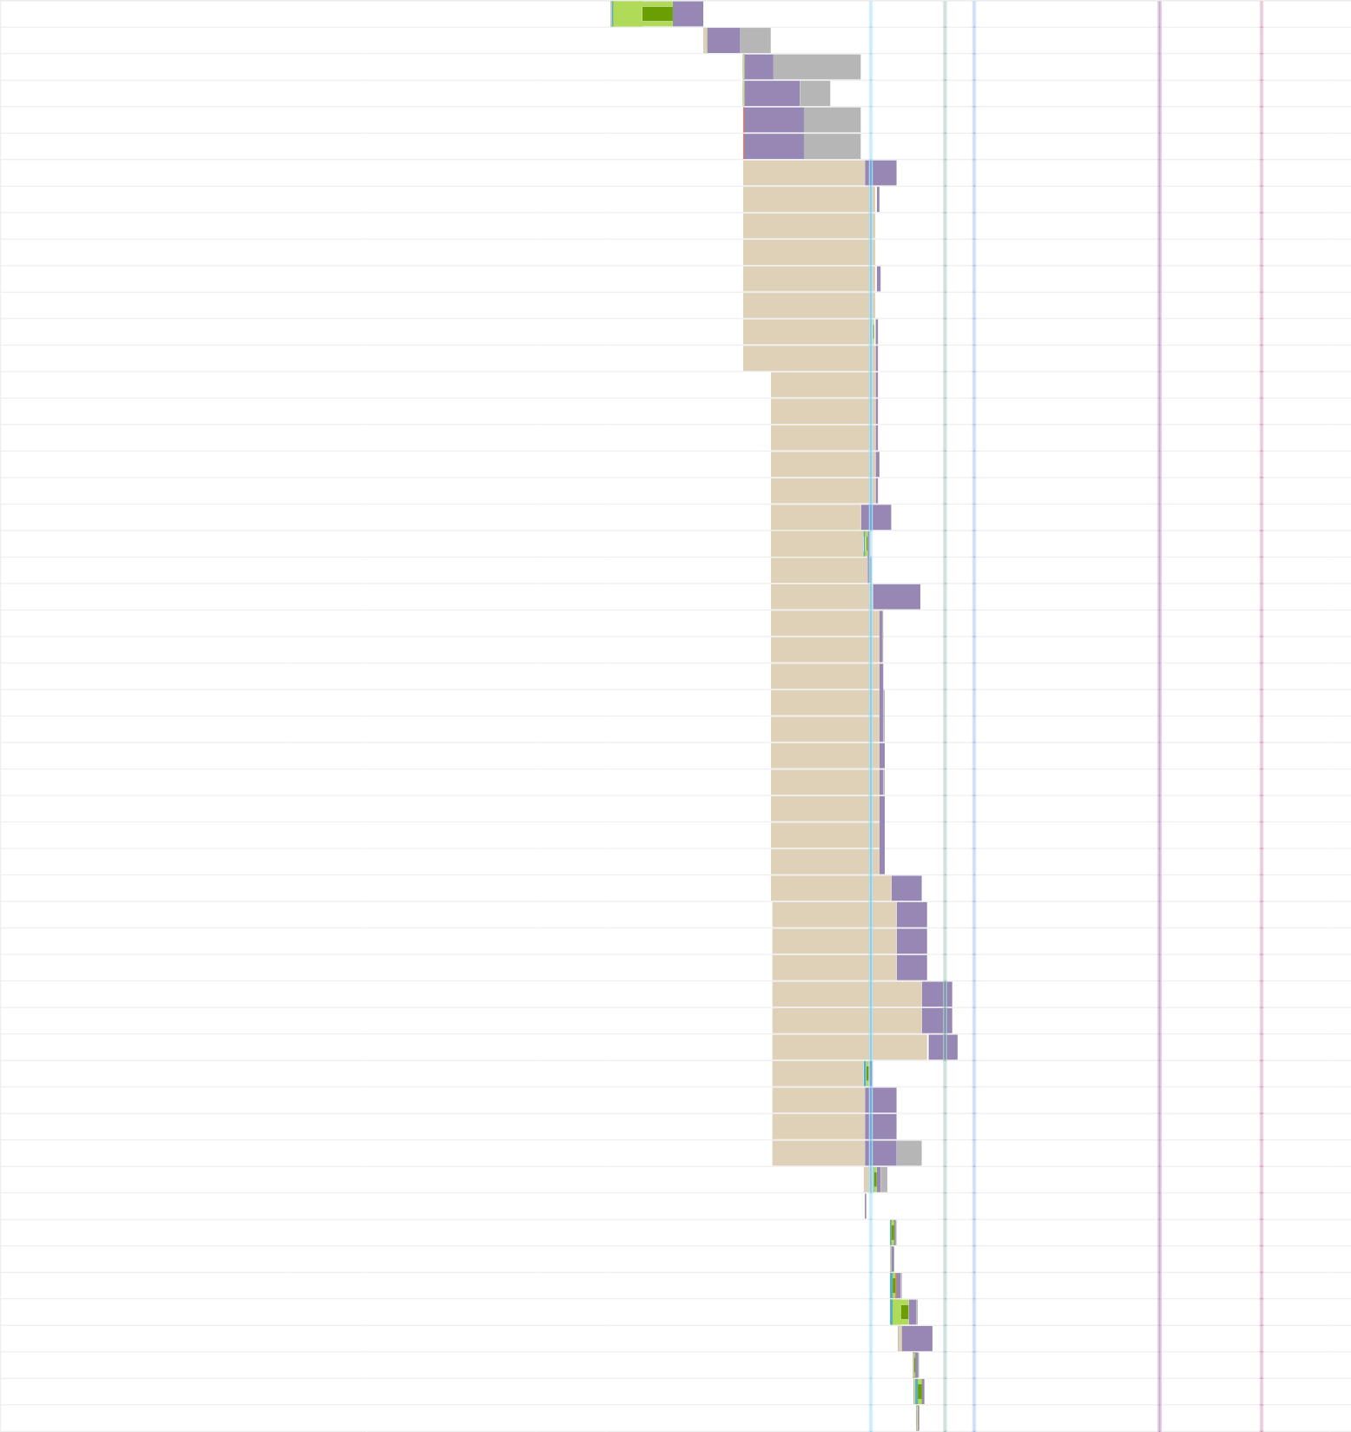**/**

**/**

**fontawesome-webfont.woff2?v=4.7.0 barlow-light.woff2 eicbwpoqj0rjb4jv0k9icjurwnclsfjwbw… yldgt0krvaqvzbtuoxpchqyrauhtbekey… certified_icon.png**

**0195000_20.png**

**0195008_20.png**

**0195003_20.png**

**0195022_20.png**

**0195005_20.png**

**0195011_20.png**

**0195012_20.png**

**0267621_20.png**

**0355255_20.png**

**0320210_20.png**

**0195026_20.png**

**0194842.png**

**algoliasearch.min.js instantsearch.min.css instantsearch.min.js user-login-icon.png 0359778.jpeg 0359893.jpeg 0360185.jpeg 0357598.jpeg 0360042.jpeg 0357583.jpeg 0345157.jpeg 0358232.jpeg 0351035.jpeg 0351136.jpeg**

**othoba-loader.jpg bkash_icon.png visa-icon.png**

**mastercard-icon.png american-express.png qcash.png**

**upay.png**

**reve-chat-widget-1.0.css footer.js**

**nvhtsxf8vg4w2ehvzpqz1tgizswc9fixv… 9a3gpejlrfneb5ixqj6e2jzf9xuj-ebth0cg… gtm.js?id=GTM-5L4V35**

**fontawesome-webfont.woff2?v=4.7.0 analytics.js**

**js?id=G-NSR03F2XBK&l=dataLayer&… conversion_async.js**

**fbevents.js cart-icon.ttf**

**js?id=GTM-W67RXJC&t=gtm4 877033501?random=1635328552608&…**

**configuration.js**

301 othoba.com 134B

200 othoba.com 30.6KB

200 othoba.com 55.4KB

200 othoba.com 25.8KB

200 othoba.com 94.8KB

200 othoba.com 47.1KB

200 othoba.com 7.97KB

200 images.othoba.com 228B

200 images.othoba.com 234B

200 images.othoba.com 268B

200 images.othoba.com 366B

200 images.othoba.com 276B

200 images.othoba.com 200B

200 images.othoba.com 280B

200 images.othoba.com 290B

200 images.othoba.com 292B

200 images.othoba.com 350B

200 images.othoba.com 166B

200 images.othoba.com 3.49KB

200 othoba.com 26.5KB

200 cdn.jsdelivr.net 4.07KB

200 cdn.jsdelivr.net 92.6KB

200 othoba.com 1.45KB

200 images.othoba.com 103KB

200 images.othoba.com 120KB

200 images.othoba.com 123KB

200 images.othoba.com 168KB

200 images.othoba.com 116KB

200 images.othoba.com 85.6KB

200 images.othoba.com 118KB

200 images.othoba.com 67.5KB

200 images.othoba.com 75.1KB

200 images.othoba.com 86.1KB

200 othoba.com 2.70KB

200 othoba.com 3.08KB

200 othoba.com 2.92KB

200 othoba.com 3.51KB

200 othoba.com 4.37KB

200 othoba.com 5.59KB

200 othoba.com 5.35KB

200 static.revechat.com 685B

200 othoba.com 1.92KB

200 othoba.com 4.74KB

200 othoba.com 102KB

200 googletagmanager.com 52.2KB

200 othoba.com 0

200 google-analytics.com 19.3KB

200 googletagmanager.com 48.2KB

200 googleadservices.com 14.1KB

200 connect.facebook.net 25.4KB

200 othoba.com 1.63KB

200 google-analytics.com 33.8KB

200 googleads.g.doublecli… 1.01KB

200 static.revechat.com 3.31KB

584ms

423ms

741ms 552ms

740ms 740ms

966ms 856ms 854ms 850ms 869ms 853ms 854ms 854ms 679ms 676ms 678ms 683ms 677ms

760ms 622ms 635ms

946ms 706ms 708ms 711ms 716ms 713ms 717ms 717ms 718ms 718ms 718ms

951ms 983ms 984ms 983ms

1.1s

* 1. s
  2. s

642ms

786ms 787ms

942ms 150ms

3ms

43ms 26ms 74ms

172ms

220ms 40ms 65ms 14ms

|  |  |  |  |  |  |  |  |  |  |  |  |  |  |  |  |  |  |  |
| --- | --- | --- | --- | --- | --- | --- | --- | --- | --- | --- | --- | --- | --- | --- | --- | --- | --- | --- |
| **336551680604150?v=2.9.47&r=stable** | 200 | connect.facebook.net | 86.9KB |  |  | 20 | | 4ms | | | | | | | | |  |  |
| **GetSpecialBlock** | 200 | othoba.com | 68.1KB |  |  |  |  | 235ms | | | | | | | | |  |  |
| **OnLoadProduct?_=1635328552289** | 200 | othoba.com | 97.0KB |  |  |  |  | 234ms | | | | | | | | |  |  |
| **ec.js** | 200 | google-analytics.com | 2.74KB |  | 7m | s | |  | | | | | | | | |  |  |
| **select-bg.png** | 200 | othoba.com | 1.19KB |  |  |  |  | 214ms | | | | | | | | |  |  |
| **icon_facebook.png** | 200 | s3-us-west-2.amazon… | 1.53KB |  |  | 83m | | s | | | | | | | | |  |  |
|  |
|  |
| **slick.woff** | 200 | othoba.com | 1.35KB |  | |  | |  | 273ms | | | | | | | |  |  |
| **ajax-loader.gif** | 200 | othoba.com | 4.08KB |  | |  | | 194ms | | | | | | | | |  |  |
| **POST GetDealsCount** | 200 | othoba.com | 26B |  | |  | | 197ms | | | | | | | | |  |  |
| **ajaxLoader.gif** | 200 | othoba.com | 4.08KB |  | |  | |  | | | 371ms | | | | | |  |  |
| **0358378.jpeg** | 200 | images.othoba.com | 135KB |  | | 21m | | s | | | | | | | | |  |  |
| **client_version_2.html?1635328552796** | 200 | static.revechat.com | 461KB |  | |  | |  | | | | | | | 823ms | |  |  |
| **0359381.jpeg** | 200 | images.othoba.com | 38.6KB |  | | 21 | | ms | | | | | | | | |  |  |
| **0351442.jpeg** | 200 | images.othoba.com | 31.3KB |  | | 26 | | ms | | | | | | | | |  |  |
| **0357794.jpeg** | 200 | images.othoba.com | 35.3KB |  | | 16m | | s | | | | | | | | |  |  |
| **0358805.jpeg** | 200 | images.othoba.com | 42.7KB |  | | 25 | | ms | | | | | | | | |  |  |
| **877033501?random=1635328552608&…** | 200 | google.com | 42B |  | |  |  | 74ms | | | | | | | | |  |  |
| **877033501?random=1635328552608&…** | 200 | google.ca | 42B |  | |  |  | 75ms | | | | | | | | |  |  |
| **tr?id=336551680604150&ev=PageVie…** | 200 | facebook.com | 44B |  | |  | | 35ms | | | | | | | | |  |  |
| **tr?id=336551680604150&ev=ViewCate…** | 200 | facebook.com | 44B |  | |  | | 45ms | | | | | | | | |  |  |
| **0356946.jpeg** | 200 | images.othoba.com | 47.5KB |  | |  | |  | | 16ms | | | | | | |  |  |
| **0352588.jpeg** | 200 | images.othoba.com | 53.7KB |  | |  | |  | | 18ms | | | | | | |  |  |
| **0352823.jpeg** | 200 | images.othoba.com | 37.8KB |  | |  | |  | | 18ms | | | | | | |  |  |
| **0360209_food-grocery-corner.jpeg** | 200 | images.othoba.com | 70.7KB |  | |  | |  | | 24ms | | | | | | |  |  |
| **0340023.jpeg** | 200 | images.othoba.com | 92.9KB |  | |  | |  | | 26ms | | | | | | |  |  |
| **0357248.jpeg** | 200 | images.othoba.com | 96.9KB |  | |  | |  | | 28ms | | | | | | |  |  |
| **0328123.jpeg** | 200 | images.othoba.com | 39.9KB |  | |  | |  | | 25ms | | | | | | |  |  |
| **0329145_explore-womens-fashion.jpeg** | 200 | images.othoba.com | 43.9KB |  | |  | |  | | 29ms | | | | | | |  |  |
| **0328981.jpeg** | 200 | images.othoba.com | 64.2KB |  | |  | |  | | 29ms | | | | | | |  |  |
| **0336675.jpeg** | 200 | images.othoba.com | 84.9KB |  | |  | |  | | 30ms | | | | | | |  |  |
| **0328902.jpeg** | 200 | images.othoba.com | 65.3KB |  | |  | |  | | 30ms | | | | | | |  |  |
| **0336582.jpeg** | 200 | images.othoba.com | 66.8KB |  | |  | |  | | 31ms | | | | | | |  |  |
| **0308796_mexican-mini-burger_300.jpeg** | 200 | images.othoba.com | 20.2KB |  | |  | |  | | | | 36ms | | | | |  |  |
| **0308795_chicken-momo-combo-6pcs…** | 200 | images.othoba.com | 12.6KB |  | |  | |  | | | | 92ms | | | | |  |  |
| **0289400_mexican-shashlik_300.jpeg** | 200 | images.othoba.com | 10.8KB |  | |  | |  | | | |  | 82ms | | | |  |  |
| **0289242_baked-pasta-250gm_300.jpeg** | 200 | images.othoba.com | 17.0KB |  | |  | |  | | | |  | 87ms | | | |  |  |
| **0308794_mexican-club-burger_300.jpeg** | 200 | images.othoba.com | 20.2KB |  | |  | |  | | | | 88ms | | | | |  |  |
| **0308793_mexican-sub-sandwich_300.…** | 200 | images.othoba.com | 19.1KB |  | |  | |  | | | | 88ms | | | | |  |  |
| **0308791_chicken-puff-90-gm-_300.jpeg** | 200 | images.othoba.com | 15.2KB |  | |  | |  | | | | 89ms | | | | |  |  |
| **0308790_chicken-patties-60gm-_300.j…** | 200 | images.othoba.com | 13.3KB |  | |  | |  | | | | 90ms | | | | |  |  |
| **0115717_mithai-premium-salty-cooki…** | 200 | images.othoba.com | 9.23KB |  | |  | |  | | | |  | | 183ms | | |  |  |
| **0309237_opera-pastry-120gm-_300.jpeg** | 200 | images.othoba.com | 17.0KB |  | |  | |  | | | | 91ms | | | | |  |  |
| **0007405_pran-aromatic-chinigura-pre…** | 200 | images.othoba.com | 23.6KB |  | |  | |  | | | | 91ms | | | | |  |  |
| **0053865_rupchanda-soyabean-oil-5ltr…** | 200 | images.othoba.com | 36.2KB |  | |  | |  | | | |  | | | | 661m | s |  |
| **0244752_daily-shopping-mushur-dal-…** | 200 | images.othoba.com | 30.4KB |  | |  | |  | | | | 92ms | | | | |  |  |
| **0299726_onion-local-1-kg_300.jpeg** | 200 | images.othoba.com | 39.2KB |  | |  | |  | | | |  | 104ms | | | |  |  |
| **0251263_low-sugar-grade-potato-1kg…** | 200 | images.othoba.com | 24.6KB |  | |  | |  | | | |  | 105ms | | | |  |  |
| **0271355_farm-egg-30pcs-combo_300…** | 200 | images.othoba.com | 16.3KB |  | |  | |  | | | |  | 105ms | | | |  |  |
| **0308033_unilever-water-purifier-purei…** | 200 | images.othoba.com | 11.8KB |  | |  | |  | | | |  | 106ms | | | |  |  |
| **0043355_green-banana-per-piece_30…** | 200 | images.othoba.com | 29.7KB |  | |  | |  | | | |  | 107ms | | | |  |  |
| **0200779_brinjal-long-1-kg_300.jpeg** | 200 | images.othoba.com | 17.0KB |  | |  | |  | | | |  | 107ms | | | |  |  |
| **0301871_pran-drinking-water-6ltr_300…** | 200 | images.othoba.com | 15.0KB |  | |  | |  | | | |  | 108ms | | | |  |  |
| **0270581_jhatpot-chicken-mini-samos…** | 200 | images.othoba.com | 14.5KB |  | |  | |  | | | |  | 108ms | | | |  |  |
| **0308236_jhatpot-deshi-paratha-family…** | 200 | images.othoba.com | 27.8KB |  | |  | |  | | | |  | 109ms | | | |  |  |
| **0051810_pran-full-cream-milk-powder…** | 200 | images.othoba.com | 16.7KB |  | |  | |  | | | |  | 109ms | | | |  |  |
| **0071404_pran-latina-orange-juice-100…** | 200 | images.othoba.com | 16.2KB |  | |  | |  | | | |  | 110ms | | | |  |  |
| **0073688_pran-tomatosauce-340gm_3…** | 200 | images.othoba.com | 13.1KB |  | |  | |  | | | |  | | 180ms | | |  |  |
| **0304205_harpic-lizol-combo-pack_30…** | 200 | images.othoba.com | 27.8KB |  | |  | |  | | | |  | 110ms | | | |  |  |
| **0304170_mamy-poko-pants-m-52-pcs…** | 200 | images.othoba.com | 23.8KB |  | |  | |  | | | |  | 111ms | | | |  |  |
| **0302386_danish-full-cream-milk-pow…** | 200 | images.othoba.com | 23.2KB |  | |  | |  | | | |  | 111ms | | | |  |  |
| **0309231_premium-white-black-forest-…** | 200 | images.othoba.com | 23.6KB |  | |  | |  | | | |  | 112ms | | | |  |  |
| **0309228_premium-red-velvet-cake-1k…** | 200 | images.othoba.com | 22.9KB |  | |  | |  | | | |  |  | 178ms | | |  |  |

|  |  |  |  |  |  |  |  |  |  |  |  |  |  |
| --- | --- | --- | --- | --- | --- | --- | --- | --- | --- | --- | --- | --- | --- |
| **0309226_white-forest-cake-1kg_300.j…** | 200 | images.othoba.com | 33.7KB |  |  |  |  | | | 649m | | s |  |
| **0310370_choco-vanilla-cake-1kg_300.…** | 200 | images.othoba.com | 41.3KB |  |  |  |  | | | 658m | | s |  |
| **0309214_chocolate-cake-1kg_300.jpeg** | 200 | images.othoba.com | 22.7KB |  |  |  |  |  | 183ms | | |  |  |
| **0310374_black-forest-cake-1kg_300.j…** | 200 | images.othoba.com | 20.9KB |  |  |  |  |  | 183ms | | |  |  |
| **0309211_vanilla-cake-1kg_300.jpeg** | 200 | images.othoba.com | 19.5KB |  |  |  |  |  | 183ms | | |  |  |
| **0303633_mithai-dry-roshgolla-1kg_30…** | 200 | images.othoba.com | 5.74KB |  |  |  |  |  | 177ms | | |  |  |
| **0303661_mithai-dry-kalojam-1kg_300.…** | 200 | images.othoba.com | 7.01KB |  |  |  |  |  | 177ms | | |  |  |
| **0303643_mithai-kacha-sondesh-1kg_…** | 200 | images.othoba.com | 8.49KB |  |  |  |  |  | 178ms | | |  |  |
| **0303635_mithai-balushai-1kg_300.jpeg** | 200 | images.othoba.com | 11.9KB |  |  |  |  |  | 178ms | | |  |  |
| **0303626_mithai-rush-kodom-1kg_300…** | 200 | images.othoba.com | 6.79KB |  |  |  |  |  | 176ms | | |  |  |
| **0303631_mithai-mihidana-laddu-1kg_…** | 200 | images.othoba.com | 9.23KB |  |  |  |  |  | 178ms | | |  |  |
| **0303629_mithai-motichur-orange-lad…** | 200 | images.othoba.com | 9.8KB |  |  |  |  |  | 178ms | | |  |  |
| **0303637_mithai-hafshi-shondesh_300…** | 200 | images.othoba.com | 12.7KB |  |  |  |  |  | 177ms | | |  |  |
| **0303648_mithai-vogsagor-1-kg_300.j…** | 200 | images.othoba.com | 6.60KB |  |  |  |  |  | 176ms | | |  |  |
| **0303655_mithai-cream-jam-1kg_300.j…** | 200 | images.othoba.com | 8.11KB |  |  |  |  |  | 177ms | | |  |  |
| **0210439_dettol-antiseptic-liquid-brow…** | 200 | images.othoba.com | 27.1KB |  |  |  |  |  | 183ms | | |  |  |
| **0210459_dettol-antiseptic-liquid-brow…** | 200 | images.othoba.com | 26.9KB |  |  |  |  |  | 183ms | | |  |  |
| **0210451_dettol-antiseptic-liquid-brow…** | 200 | images.othoba.com | 18.3KB |  |  |  |  |  | 183ms | | |  |  |
| **0210468_dettol-antiseptic-liquid-brow…** | 200 | images.othoba.com | 18.3KB |  |  |  |  |  | 183ms | | |  |  |
| **0266098_dettol-handwash-cool-liquid…** | 200 | images.othoba.com | 17.3KB |  |  |  |  |  | 183ms | | |  |  |
| **0231009_dettol-handwash-pouch-coo…** | 200 | images.othoba.com | 27.0KB |  |  |  |  |  | 198ms | | |  |  |
| **0231017_dettol-handwash-pouch-re-e…** | 200 | images.othoba.com | 57.1KB |  |  |  |  | | | |  | 843ms |  |
| **0233456_dettol-handwash-re-energiz…** | 200 | images.othoba.com | 20.8KB |  |  |  |  |  | 198ms | | |  |  |
| **0233486_dettol-handwash-re-energiz…** | 200 | images.othoba.com | 26.5KB |  |  |  |  |  | 200ms | | |  |  |
| **0058987_lifebuoy-care-handwash-liq…** | 200 | images.othoba.com | 19.7KB |  |  |  |  | | 198ms | | |  |  |
| **0058981_lifebuoy-care-handwash-liq…** | 200 | images.othoba.com | 13.7KB |  |  |  |  |  | 183ms | | |  |  |
| **0058984_lifebuoy-total-handwash-liq…** | 200 | images.othoba.com | 11.6KB |  |  |  |  |  | 183ms | | |  |  |
| **0278276_vision-51-home-theater-fusi…** | 200 | images.othoba.com | 10.5KB |  |  |  |  | | 183ms | | |  |  |
| **0285886_vision-evaporative-air-coole…** | 200 | images.othoba.com | 8.36KB |  |  |  |  |  | 183ms | | |  |  |
| **0252705_vigo-blender-vis-sbl-003-ss_…** | 200 | images.othoba.com | 14.5KB |  |  |  |  | | 197ms | | |  |  |
| **0252691_vision-blender-comfort-vis-s…** | 200 | images.othoba.com | 14.5KB |  |  |  |  |  | 197ms | | |  |  |
| **0210865_rfl-wardrobe-double-5d-kd-e…** | 200 | images.othoba.com | 31.2KB |  |  |  |  |  | 202ms | | |  |  |
| **0210881_rfl-wardrobe-double-5d-kd-d…** | 200 | images.othoba.com | 33.0KB |  |  |  |  |  | 202ms | | |  |  |
| **0201520_rfl-wardrobe-double-5d-k-do…** | 200 | images.othoba.com | 32.6KB |  |  |  |  |  | 202ms | | |  |  |
| **0105126_amass-closet-5-drawer-cam…** | 200 | images.othoba.com | 16.7KB |  |  |  |  | | 200ms | | |  |  |
| **0278521_regal-dressing-table_300.jpeg** | 200 | images.othoba.com | 6.27KB |  |  |  |  |  | 194ms | | |  |  |
| **0052032_laminated-board-dressing-ta…** | 200 | images.othoba.com | 6.17KB |  |  |  |  |  | 194ms | | |  |  |
| **0035062_dining-table_300.jpeg** | 200 | images.othoba.com | 7.86KB |  |  |  |  |  | 196ms | | |  |  |
| **0049210_regal-wooden-bed-king-size…** | 200 | images.othoba.com | 11.1KB |  |  |  |  |  | 198ms | | |  |  |
| **0212128_rodo-smart-chair-sm-blue_3…** | 200 | images.othoba.com | 6.98KB |  |  |  |  | | 198ms | | |  |  |
| **0084408_classroom-chair-modern-sm…** | 200 | images.othoba.com | 12.7KB |  |  |  |  |  | 199ms | | |  |  |
| **0062756_royal-rok-chair-red_300.jpeg** | 200 | images.othoba.com | 9.67KB |  |  |  |  |  | 199ms | | |  |  |
| **0285429_-_300.jpeg** | 200 | images.othoba.com | 16.1KB |  |  |  |  | | 201ms | | |  |  |
| **0285222_-_300.jpeg** | 200 | images.othoba.com | 26.5KB |  |  |  |  |  | 202ms | | |  |  |
| **0284931_-_300.jpeg** | 200 | images.othoba.com | 34.8KB |  |  |  |  |  | 204ms | | |  |  |
| **0283561_-_300.jpeg** | 200 | images.othoba.com | 6.45KB |  |  |  |  |  | 197ms | | |  |  |
| **0283090_-_300.jpeg** | 200 | images.othoba.com | 22.8KB |  |  |  |  |  | 200ms | | |  |  |
| **0281983_-_300.jpeg** | 200 | images.othoba.com | 10.7KB |  |  |  |  |  | 200ms | | |  |  |
| **0279319_-_300.jpeg** | 200 | images.othoba.com | 24.9KB |  |  |  |  | | 203ms | | |  |  |
| **0279146_-_300.jpeg** | 200 | images.othoba.com | 14.8KB |  |  |  |  |  | 200ms | | |  |  |
| **0276575_-_300.jpeg** | 200 | images.othoba.com | 17.9KB |  |  |  |  |  | 201ms | | |  |  |
| **0244666_-_300.jpeg** | 200 | images.othoba.com | 9.67KB |  |  |  |  | | 200ms | | |  |  |
| **0197300_-_300.jpeg** | 200 | images.othoba.com | 31.7KB |  |  |  |  | | 217ms | | |  |  |
| **0169731_-_300.jpeg** | 200 | images.othoba.com | 16.8KB |  |  |  |  | | 201ms | | |  |  |
| **0161575_-_300.jpeg** | 200 | images.othoba.com | 26.8KB |  |  |  |  | | 203ms | | |  |  |
| **0161532_-_300.jpeg** | 200 | images.othoba.com | 32.0KB |  |  |  |  | | 216ms | | |  |  |
| **0158379_-_300.jpeg** | 200 | images.othoba.com | 29.6KB |  |  |  |  |  | 202ms | | |  |  |
| **0279731_-_300.jpeg** | 200 | images.othoba.com | 20.1KB |  |  |  |  |  | 200ms | | |  |  |
| **0279269_300.jpeg** | 200 | images.othoba.com | 34.1KB |  |  |  |  | | 217ms | | |  |  |
| **0278774_-_300.jpeg** | 200 | images.othoba.com | 19.2KB |  |  |  |  | | 215ms | | |  |  |
| **0278314_300.jpeg** | 200 | images.othoba.com | 22.0KB |  |  |  |  | | 215ms | | |  |  |
| **0279307_-_300.jpeg** | 200 | images.othoba.com | 18.9KB |  |  |  |  | | 215ms | | |  |  |

|  |  |  |  |  |  |  |  |  |  |  |  |
| --- | --- | --- | --- | --- | --- | --- | --- | --- | --- | --- | --- |
| **0285258_-_300.jpeg** | 200 | images.othoba.com | 24.0KB |  |  |  |  | 216ms |  | | |
| **0251096_-_300.jpeg** | 200 | images.othoba.com | 23.9KB |  |  |  |  | 215ms |  |  |  |
| **0251855_-_300.jpeg** | 200 | images.othoba.com | 21.6KB |  |  |  |  | 216ms |  |  |  |
| **0304962_-_300.jpeg** | 200 | images.othoba.com | 20.8KB |  |  |  |  | 221ms |  |  |  |
| **0278729_-_300.jpeg** | 200 | images.othoba.com | 58.4KB |  |  |  |  |  | 827ms |  |  |
| **0283779_300.jpeg** | 200 | images.othoba.com | 27.1KB |  |  |  |  | 221ms |  |  |  |
| **0357600_smartphone.jpeg** | 200 | images.othoba.com | 76.4KB |  |  |  |  | 92ms |  |  |  |
| **0333538.jpeg** | 200 | images.othoba.com | 17.5KB |  |  |  |  | 88ms |  |  |  |
| **0360054.jpeg** | 200 | images.othoba.com | 16.4KB |  |  |  |  | 92ms |  |  |  |
| **0333539.jpeg** | 200 | images.othoba.com | 14.2KB |  |  |  |  | 89ms |  |  |  |
| **0333548.jpeg** | 200 | images.othoba.com | 16.5KB |  |  |  |  | 88ms |  |  |  |
| **0333549.jpeg** | 200 | images.othoba.com | 16.4KB |  |  |  |  | 90ms |  |  |  |
| **0333550.jpeg** | 200 | images.othoba.com | 19.2KB |  |  |  |  | 89ms |  |  |  |
| **0333551.jpeg** | 200 | images.othoba.com | 17.3KB |  |  |  |  | 91ms |  |  |  |
| **0333552.jpeg** | 200 | images.othoba.com | 16.5KB |  |  |  |  | 86ms |  |  |  |
| **queue-screen-img.png** | 200 | static.revechat.com | 2.38KB |  |  |  |  |  | 14ms |  |  |
| **audio-call-avatar.png** | 200 | static.revechat.com | 4.62KB |  |  |  |  |  | 17ms |  |  |
| **co-browse.png?9** | 200 | static.revechat.com | 2.28KB |  |  |  |  |  | 15ms |  |  |
| **notify.mp3** | 206 | static.revechat.com | 10.2KB |  |  |  |  |  | 15ms |  |  |
| **instantsearch.min.css** | 200 | cdn.jsdelivr.net | 0 |  |  |  |  |  | 1ms |  |  |
| **favicon.ico** | 200 | othoba.com | 2.17KB |  |  |  |  |  |  | 196ms |  |
| **revechat.ttf?1hp4ma** | 200 | static.revechat.com | 26.7KB |  |  |  |  |  |  | 37ms |  |
| **tr?id=336551680604150&ev=Microdat…** | 302 | facebook.com | 0 |  |  |  |  |  |  | 18ms |  |
| **?c=3640964387118259224&f=AYzvZjj8…** | 200 | cx.atdmt.com | 572B |  |  |  |  |  |  |  | 231ms |

**202 Requests 5.64MB (8.55MB Uncompressed) Fully Loaded 4.1s (Onload 3.4s)**

# Performance



0.4s 0.8s 1.2s 1.6s 2s 2.5s 2.9s 3.3s 3.7s 4.1s

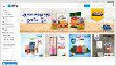

First Contentful Paint: 1.6s

Time to Interactive: 3.4s

Fully Loaded Time: 4.1s

Largest Contentful Paint: 2.3s

Onload Time: 3.4s

|  |
| --- |
|  |
| TTFB: 819ms |
| Redirect: 585ms Connect: 23ms Backend: 211ms |

Performance Metrics

0.54

2.3s

Much more than recommended

Cumulative Layout Shift

How much your page's layout shifts as it loads. A good user experience is a score of 0.1 or less.

Longer than recommended

Largest Contentful Paint

How long it takes for the largest element of content (e.g. a hero image) to be painted on your page. A good user experience is 1.2s or less.

487ms

4.7s

Much longer than recommended

Total Blocking Time

How much time is blocked by scripts during your page loading process. A good user experience is 150ms or less.

Much longer than recommended

Speed Index

How quickly the contents of your page are visibly populated. A good user experience is 1.3s or less.

3.4s

1.6s

Longer than recommended

Time to Interactive

How long it takes for your page to become fully

interactive. A good user experience is 2.5s or less.

Much longer than recommended

First Contentful Paint

How quickly content like text or images are painted onto your page. A good user experience is 0.9s or less.

Browser Timings

|  |  |  |  |  |  |  |  |  |  |
| --- | --- | --- | --- | --- | --- | --- | --- | --- | --- |
|  | | | | | | | | |  |
|  | Redirect | 585ms |  | Connect | 23ms |  | Backend | 211ms |
|  | | | | | | | | | |
|  | TTFB | 819ms |  | First Paint | 1.6s |  | DOM Int. | 2.0s |  |
|  | | | | | | | | | |
|  | DOM Loaded | 2.1s |  | Onload | 3.4s |  | Fully Loaded | 4.1s |  |
|  | | | | | | | | |

Structure Audits



**IMPACT AUDIT**

|  |  |  |
| --- | --- | --- |
| High | **Avoid enormous network payloads** | Total size was 5.74MB |
| Med-High | **Avoid an excessive DOM size** | 4,261 elements |
| Med | **Avoid large layout shifts** | 5 elements found |
| Med-Low | **Serve static assets with an efficient cache policy** | Potential savings of 286KB |
| Med-Low | **Use a Content Delivery Network (CDN)** | 20 resources found |
| Med-Low | **Avoid document.write()** | 1 instance found |
| Med-Low | **Avoid chaining critical requests** | 11 chains found |
| Med-Low | **Avoid long main-thread tasks** | 8 long tasks found |
| Low | **Use passive listeners to improve scrolling performance** | 1 event listener not passive |
| Low | **Ensure text remains visible during webfont load** | 5 fonts found |
| Low | **Eliminate render-blocking resources** | Potential savings of 16ms |
| Low | **Reduce JavaScript execution time** | 630ms spent executing JavaScript |
| Low | **Reduce unused JavaScript** | Potential savings of 273KB |
| Low | **Enable text compression** | Potential savings of 153KB |
| Low | **Properly size images** | Potential savings of 1.44MB |
| Low | **Avoid multiple page redirects** | Potential savings of 584ms |
| Low | **Efficiently encode images** | Potential savings of 132KB |
| Low | **Reduce unused CSS** | Potential savings of 110KB |
| Low | **Serve images in next-gen formats** | Potential savings of 182KB |
| Low | **Reduce initial server response time** | Root document took 210ms |
| Low | **Avoid serving legacy JavaScript to modern browsers** | Potential savings of 44.1KB |
| Low | **Defer offscreen images** | Potential savings of 1.35MB |
| Low | **Avoid non-composited animations** | 169 animated elements found |

|  |  |  |
| --- | --- | --- |
| Low | **Minify JavaScript** | Potential savings of 4.15KB |
| N/A | **Largest Contentful Paint element** | 1 element found |
| N/A | **Minimize main-thread work** | Main-thread busy for 2.5s |
| N/A | **Reduce the impact of third-party code** | Total size was 387KB |
| N/A | **User Timing marks and measures** | |